2022

dheeraj savanthy

Team Argus

4/19/2022

ARGUS MUSIC RECOMMENDER WEB DEPLOYMENT



We have deployed the application using Microsoft Azure Cloud Services.

Here are the referential screenshots of the steps:

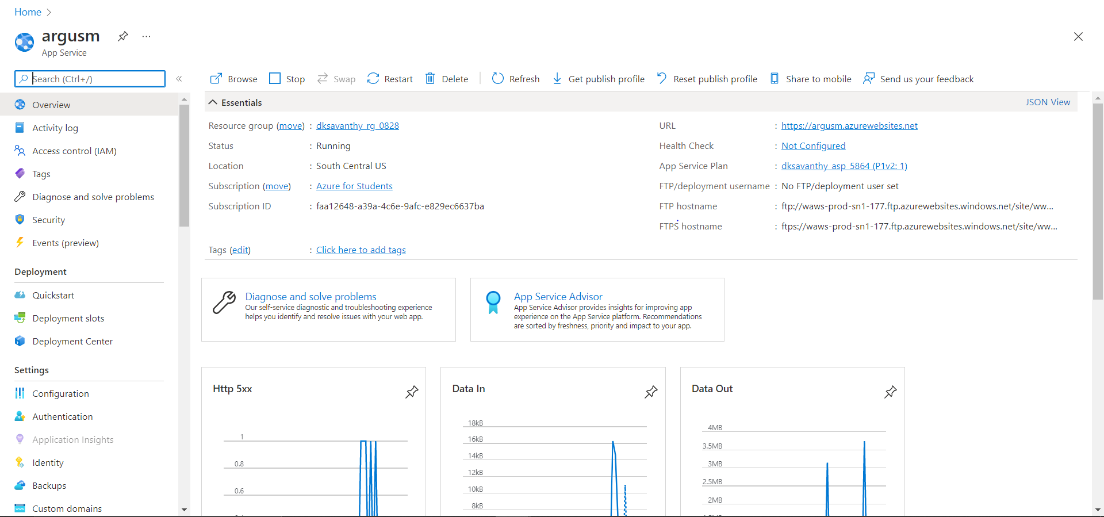

Requests and Response time metrics:

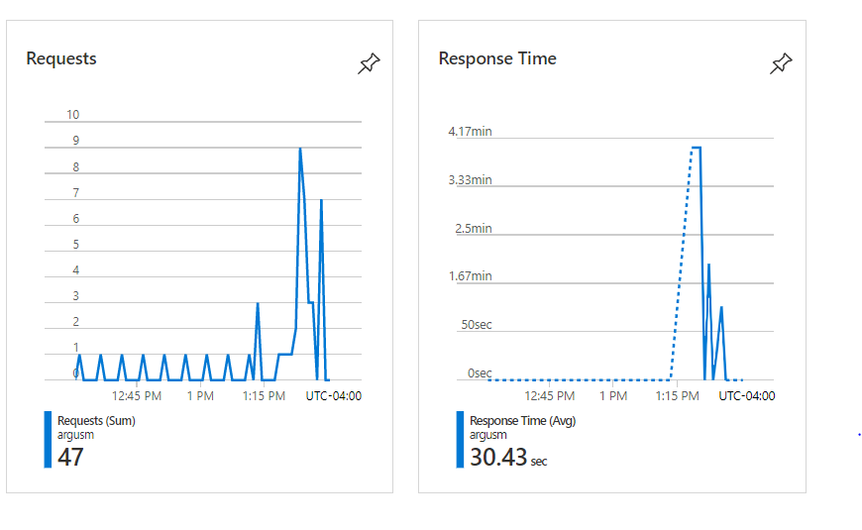

Deployed website live at: https://argusm.azurewebsites.net

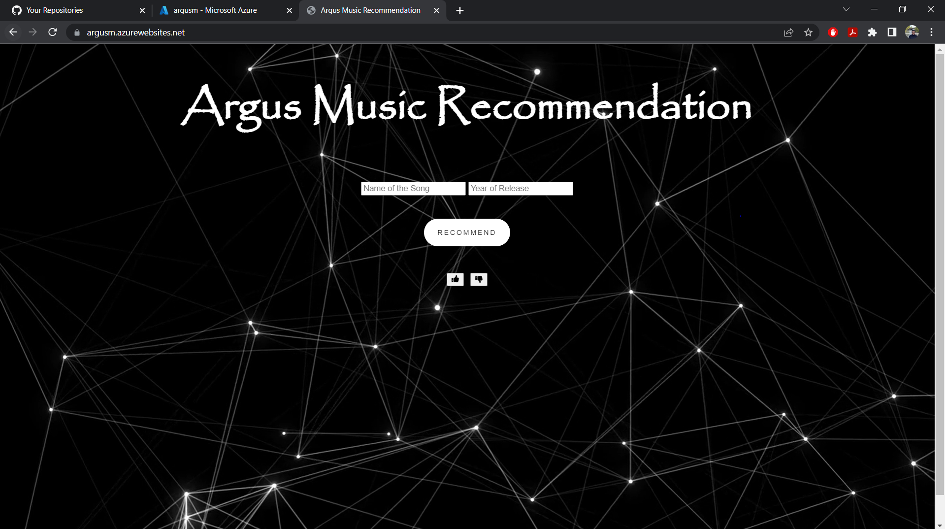

After entering the song and year, the output displayed on screen:

